We can test every feature separately, but we as well can test entire functionality in one shot

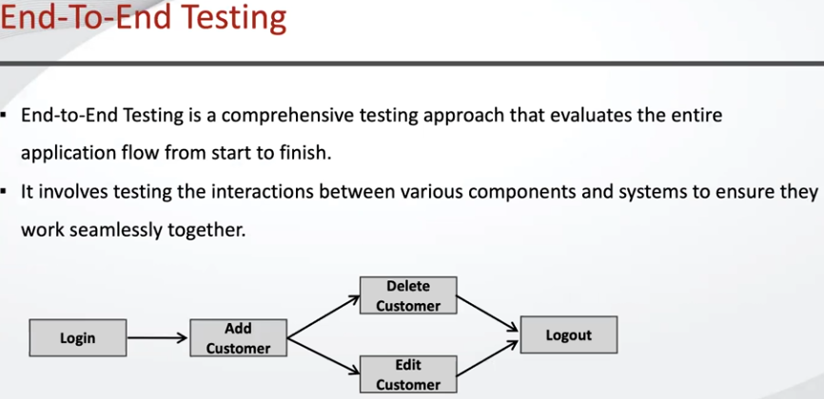

For example Ecomerce application functionality: login, user registration, search for the product, add to cart, checkout, do the payment, these are different features but regarding to End-to-end testing we can do all that in a single shot as it would be a single feature.

